SOC notes
Telemetry - Wikipedia
Top 5 SOC Analyst Certifications for 2024 - TCM Security
Network interface controller - Wikipedia
subnet mask - Search
GitHub - the-tcpdump-group/tcpdump: the TCPdump network dissector
Tcpdump:
To filter by source or destination host, use tcpdump src ip-address or tcpdump dst ip-address. To filter by port, add the port parameter and the port number, such as tcpdump dst port 25. To filter by protocol, add the protocol name, such as tcpdump ftp. Also, just like Wireshark, logical operators such as and & or can be used to chain terms. Lastly, to make TCPDump quit after capturing x number of packets, use the -c no. option.
if you are processing the capture file through a script or a series of commands – to turn this off, use the -n option. Finally, you can save your capture to a PCAP file with -w filename.
To read a saved capture file with default settings, use filename. For a more verbose output, the -v, -vv or -vvv options can be used, with each one increasing in verbosity.
ack packet - Search
Understanding TCP Flags SYN ACK RST FIN URG PSH - howtouselinux
– Specifying TCP flags:
To match all packets with a single specified TCP flag, add the tcp[tcpflags] == tcp-ack/tcp-syn/tcp-fin/tcp-push/tcp-urg/tcp-rst option. For example, tcp[tcpflags] == tcp-push displays packets with only the PSH flag set. If you want to match packets with multiple flag bits on, convert the flags into a decimal value and use this number in tcp[tcpflags] == x. For example, for packets with the PSH and ACK flags set, the decimal value becomes 00011000 = 24, and the expression becomes tcp[tcpflags] == 24, as shown below.
We know that echo requests have an ICMP type of 8. Since the type field in an ICMP header is the first byte, byte 0 (index is counted from 0) of the ICMP header should have a value of 8 (or 00001000 in binary). From this, we can construct our expression as icmp[0] == 8. The same applies for other protocol headers and values, such as ip[8] for the TTL.
Note that you can sometimes replace the byte index with the name of the field that you are specifying. For example, icmp[0] could be replaced with icmp[icmptype].
There are many other useful features in TCPDump, such as:
- -A to display packet contents in ASCII
- -x to print the hex dump of the packet
- -X to print both of the above, and
- t, -tt, -ttt, -tttt, -ttttt to manage timestamps
– cut -d “delimiter” -f no.: cut is a useful tool that can extract certain fields within each line with the use of delimiters. Delimiters are single characters that separate each field, with each field being able to be specified with a number.
You can specify more than one field to be displayed, such as cut -d “:” -f 1,2,3 to print up to the destination address and port.
Security Blue Team: Introduction to Network Analysis TCPDump Activity Write-up | by Justin Mangaoang | Medium
– awk ‘{print $no.}’: awk is a very powerful tool when it comes to text manipulation and one use case is to print a specific field within each line. Each field is separated by spaces. You can also use $NF for the last field and $(NF-x) for the (x+1)th field from the end, such as awk ‘{print $(NF-2)}’ for the third last field.
grep keyword: Even if you are a Unix CLI beginner, you will most likely know this Command. grep is the go-to command for finding lines within files that match a given keyword. For example, in order to find all FTP packets that relate to a .zip file, you can use grep zip, as shown below.
What is Ping? - GeeksforGeeks
Internet Control Message Protocol (ICMP) - GeeksforGeeks
Buffer Overflow Attack with Example - GeeksforGeeks
Malware-Traffic-Analysis.net - training exercises, traffic analysis training.
OSINT can be used to uncover the identities of cybercriminals that have poor OPSEC (operational security – the practice of hiding yourself online by disassociating your online persona with your real self). It can also be used to help find missing persons (a great example of this is Trace Labs, a non-profit organization that hosts online OSINT CTFs, which actually work to track missing people and assist law enforcement).
- Vulnerability Analyst
OSINT is a crucial part of this role. Keeping up to date with the latest publicly-announced vulnerabilities, following vulnerability researchers on social media, and information sharing is a really important part of the work these guys do. A great OSINT source is the National Vulnerability Database and using TweetDeck to monitor Twitter for vulnerability-related news and disclosures.
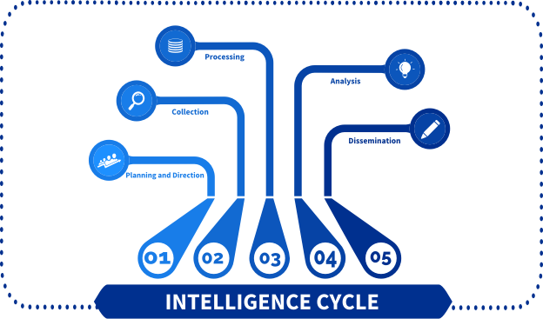
- https://www.intelligencecareers.gov/icintelligence.html
- https://www.sciencedirect.com/topics/computer-science/intelligence-cycle
- https://www.e-education.psu.edu/sgam/node/15
- https://www.groupsense.io/resources/how-to-use-the-intelligence-cycle-to-secure-your-brand
On the following websites, you can learn more about the different cookie varieties and how they allow websites to track you:
- https://www.theguardian.com/technology/2012/apr/23/cookies-and-web-tracking-intro
- https://privacy.net/stop-cookies-tracking/
- https://www.cookieyes.com/how-cookies-track-you-on-the-web-and-what-to-do-about-it/
- In fact, there are several pages that you can use to check out the information provided by your web browser. Here we will provide you 2 of them so that you can evaluate how “anonymous” you are while surfing on the Internet.

- 
- https://coveryourtracks.eff.org

- 
- https://browserleaks.com
One of the best exponents of OSINT (Michael Bazzell) mentions in his book “Open-Source Intelligence Techniques” that the best practice that an OSINT researcher can do is: Use a Linux operating system (either by USB as a Live ISO or using a VM), do your research and finally erase all trace of you by simply rebooting the system (either by using a Snapshot, or the USB live).
For this purpose, you can use some existing OSINT specialized machines like Trace Lab Osint VM, or you can create your own OSINT Linux Distribution (you will find an excellent guide for DIY Machines in one of the following links).
- TL OSINT VM: https://www.tracelabs.org/initiatives/osint-vm
- DIY OSINT VM Guide: https://nixintel.info/tag/diy-buscador/
To give you a better insight into the VPN selection process, here is an excellent guide for choosing your own VPN provider:
- https://www.secjuice.com/how-to-choose-a-virtual-private-network-vpn-provider/
Swiss privacy laws are still the best in the world. In relation to VPN services, the Swiss cyber law does not require Swiss-based VPN providers to log anything about their users, including the real IP address used to access the VPN service.
Another tip you can use to reduce the amount of information that websites obtain about you is to install extensions that block this activity. That will practically close the possibility that websites can track you or run unwanted scripts on your computer.
Some of the most recommended extensions for this purpose are the following:

User-Agent Switcher and Manager
“spoof your browser “user-agent” string to a custom designation.”

No Script
“Allows JavaScript, Java, Flash, and other plugins to be executed only by trusted web sites of your choice”

Privacy Badger
“Stops advertisers and other third-party trackers from secretly tracking where you go and what pages you look at on the web”

Ublock Origin
“Filters requests to display adverts and prevents your browser from retrieving and displaying marketing content.”

Cookie AutoDelete
“Automatically delete unwanted cookies from your closed tabs while keeping the ones you w
And finally, the best way to keep your real person separate from your digital person is by using Sock Puppets. These tools are practically the best friend of the intelligence team.
Below, you will find some of the best guides on the Internet to build your own Sock Puppet and the best advice on how to NOT build one.
- “Creating Sock Puppet Accounts”: https://YouTube.com/watch?v=Zf155HW5Qp0
- “The Art of The Sock”: https://www.secjuice.com/the-art-of-the-sock-osint-humint/
- “Creating an Effective Sock Puppet for OSINT Investigations”: https://web.archive.org/web/20210125191016/https://jakecreps.com/2018/11/02/sock-puppets/
- “Sock puppet Account Creation – My Process”: https://garrettmickley.com/sockpuppet-account-creation/
- “The World’s Best Sock Puppet…Not!”: https://keyfindings.blog/2019/01/21/the-worlds-best-sock-puppet-not/
If you want to learn more about how to get a good level of anonymity on the web or want to get more specialized training on OSINT, don’t forget to check out the links below:
- Michael Bazzell books: https://inteltechniques.com/books.html
- The PRIVACY, SECURITY, & OSINT Show (Podcast): https://inteltechniques.com/podcast.html
- Why You Need to Deal with Browser Fingerprinting: https://nixintel.info/osint/opsec-for-osint-why-you-need-to-deal-with-browser-fingerprinting/
- The Web Never Forgets: Persistent Tracking Mechanisms in the Wild: https://securehomes.esat.kuleuven.be/~gacar/persistent/the_web_never_forgets.pdf
- Tracking the OSINT Hunter: https://www.secjuice.com/tracking-osint-hunters/

The Harvester is a command-line information-gathering tool that utilizes OSINT sources to gather information about the target domain and retrieves information such as hostnames, IP addresses, employees (and their positions), email addresses, and much more. In the below screenshot, I am performing simple reconnaissance on the domain Google.com, using Google as the data source:
theharvester -d google.com -l 100 -b google
If we wanted to launch social engineering attacks against some Google employees, we can quickly identify potential targets by setting the data source to be ‘Linkedin’ instead of ‘Google’:
theharvester -d google.com -l 100 -b linkedin
Now we have a list of potential targets, along with their job titles. We can do further reconnaissance on them using Linkedin itself and build up a profile on them using a tool like Maltego, then we can launch spear-phishing attacks as part of a threat simulation engagement!
If you want to learn more about how to use this software, click on the following link and check out all the resources available on Maltego’s official site: https://www.maltego.com/categories/tutorial/
TweetDeck
As you now know, Google Dorks are very useful. Take a look at this extensive list of the different search queries you can use, and play around with a few yourself to really understand how they work, and how they could be used for defensive or offensive security. https://securitytrails.com/blog/google-hacking-techniques
Geofencing is a method of blocking entire IP ranges associated with countries so that only access from a specific location will be allowed.
IP whitelisting works in a similar way, but instead it only allows specified IP addresses to access resources, and blocks everything else.
A very effective method of preventing content being present on Google is to block their crawlers from being able to access any of the content present on the internet. This can be achieved by creating a robots.txt file that disallows any crawlers from indexing any part of your website, preventing it from showing on Google’s search engine.
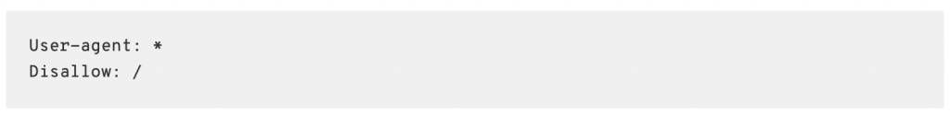
The above file will disallow any (*) user-agents from crawling any directory on the website (such as /images/ or /training/)
Information about temporary and permanent URL removals can be requested here –https://support.google.com/webmasters/answer/1663419?hl=en
This website is a hub for hundreds of OSINT sources and tools, and is easily sorted so you can find the tool that you need quickly. You can access the site here – https://osintframework.com
TinEye is an image search and recognition company, which offers customers the ability to receive alerts when their images are identified on the internet.
When people create fake social-media accounts, it’s extremely likely that they’re not using a unique photo. Chances are they’ve google something along the lines of “profile photo generator” and used one of them.
Whilst there are better ways to do this, using the TinEye Alerts service, you can be notified every time one of your images is identified on the internet. This can be useful for monitoring the use of logos, especially trademarked ones.
- Read the template “SBT-OSINT-Challenge-Report.txt” properly. This will help you gather the information you actually need, instead of falling down a rabbit-hole.
- Do not attempt to gain unauthorized access to any sites or accounts featured in this challenge, as it is illegal. There are potentially password-protected pages that are in scope and can be accessed. Do NOT attack them, try to find credentials.
- DNS TXT records can be used to show text strings. Don’t forget to check if the owner has left a comment!
- Some information may be encoded in Base64 or Hexadecimal so that it is not immediately human-readable. You can use online sites to decode them! Make sure you understand what B64 and Hexadecimal strings look like, so you can identify and convert them!
- If you get stuck, chat with other students in our Discord server, specifically in the #i2-OSINT channel (but remember, no spoilers as they breach our Discord and community rules!)
KAPE ((Kroll Artifact Parser and Extractor) is a free and open-source digital forensics tool developed by Eric Zimmerman). Designed to automate the collection and parsing of forensic artefacts from a computer's file system and memory.
FTK Imager is a massive tool that allows us to create hard drive images, but also memory images, which can be analyzed in other programs for analysis.
Just like FTK, EnCase is a suite of tools that has a wide range of functionality for digital forensics and e-Discovery. EnCase can be used to take forensic images of computers, mobile phones, and internet-of-things devices, which can then be analyzed to collect digital evidence.
Cellebrite is a suite of tools designed primarily for mobile forensics, which allows easy acquisition of data from a mobile device so it can be processed in the tools covered in the section below.
Autopsy is an open-source digital forensics tool that helps investigators analyze and extract evidence from various data sources, such as hard drives and mobile devices
Volatility is a python-based memory forensics framework that enables the analysis of memory dumps or memory images.
We also have 7 completely FREE challenges related to digital forensics. Register for free today! https://blueteamlabs.online
We don’t need to rely on the browser either – network devices such as a web proxy or router will also hold information about requested sites online, as everything will likely go through these systems.
Deleted files can be restored, old app data can be retrieved, and much more using specialist mobile forensics tools. Find out more about mobile forensics and tools here.
Materials Chain of Custody(Optional):
[1] https://financialcrimeacademy.org/evidence-gathering-and-chain-custody/
We suggest you read the following short article that explains what steganography is, written by TechTarget.
Steganography
Now we have our cover file and secret file, let’s use Steghide to hide secret.zip inside of laptop.jpg. Here’s an explanation of the command we’re using, steghide embed -cf laptop.jpg -ef secret.zip.
- steghide – Selects the tool we want to use
- embed – Selects the mode we want to use (embedding files)
- -cf laptop.jpg – Selecting the cover file (the file we want to hide data inside)
- -ef secret.zip – Selecting the file we want to embed (the file we want to hide)
If we want to create a new ‘stego’ file, we can use the -sf flag to output it to a new file. In the below screenshot we’ve used -sf laptop2.jpg
We can use the following command to retrieve the hidden file: steghide extract -sf laptop2.jpg. When prompted for the passphrase, we enter it, and the tool will extract secret.zip and place it in the current directory.
- steghide – Selects the tool we want to use
- extract – Selects the mode we want to use (extracting files)
- -sf laptop2.jpg – Selects the steganography file for extraction (combination of cover file and hidden dat
Want to know how long it would take to crack your password? Enter it at https://howsecureismypassword.net (or enter any string you want!)
The command we will be using is zip --encrypt Protected.zip text.txt.
- zip – Selects the tool we want to use
- –encrypt – Selections the function of the tool we want to use. ‘Encrypt’ will encrypt our ZIP archive and require a password to decrypt the contents.
- Protected.zip – The name of the outputted ZIP file.
- text.txt – The file we want to compress.

In this example, our target ZIP is BruteForceAttack.zip with a password of a1bc.

- fcrackzip – Selecting the tool we want to use.
- -b – Selecting the option for a brute-force attack.
- BruteForceAttack.zip – The file we want to brute-force.
- -u – This makes sure fcrackzip actually tries to unzip the file, without this we won’t actually get the right password.
- -c – This is where we pick the characters we want to use in our dictionary attack. In this example we’re using ‘a’ which represents lowercase letters, and ‘1’ which represents numbers 0-9.
- -l – This is where we state the length of the password we want to crack. If we know the password is between 4 and 6 characters, we would use "-l 4-6".
Here’s a cheat sheet with all of the potential options that can be used with fcrackzip: http://manpages.ubuntu.com/manpages/trusty/man1/fcrackzip.1.html
If you have the Offensive Security Kali image for your VM, you should already have the popular rockyou.txt wordlist installed. Find it using locate rockyou.txt and give it a read!
In this example, our target ZIP is DictionaryAttack.zip with the password ummwhateva. Here’s the command we’ll be using.
- fcrackzip – Selecting the tool we want to use.
- -D – Selecting the option for a dictionary attack.
- -u – This makes sure fcrackzip actually tries to unzip the file, without this we won’t actually get the right password.
- -p – Use strings as password.
- /usr/share/wordlists/rockyou.txt – This is the location of our wordlist, required to perform a dictionary attack.
- DictionaryAttack.zip – The file we want to crack.
I am going to run the tree command, which helps list the files and directories of the entire folder. 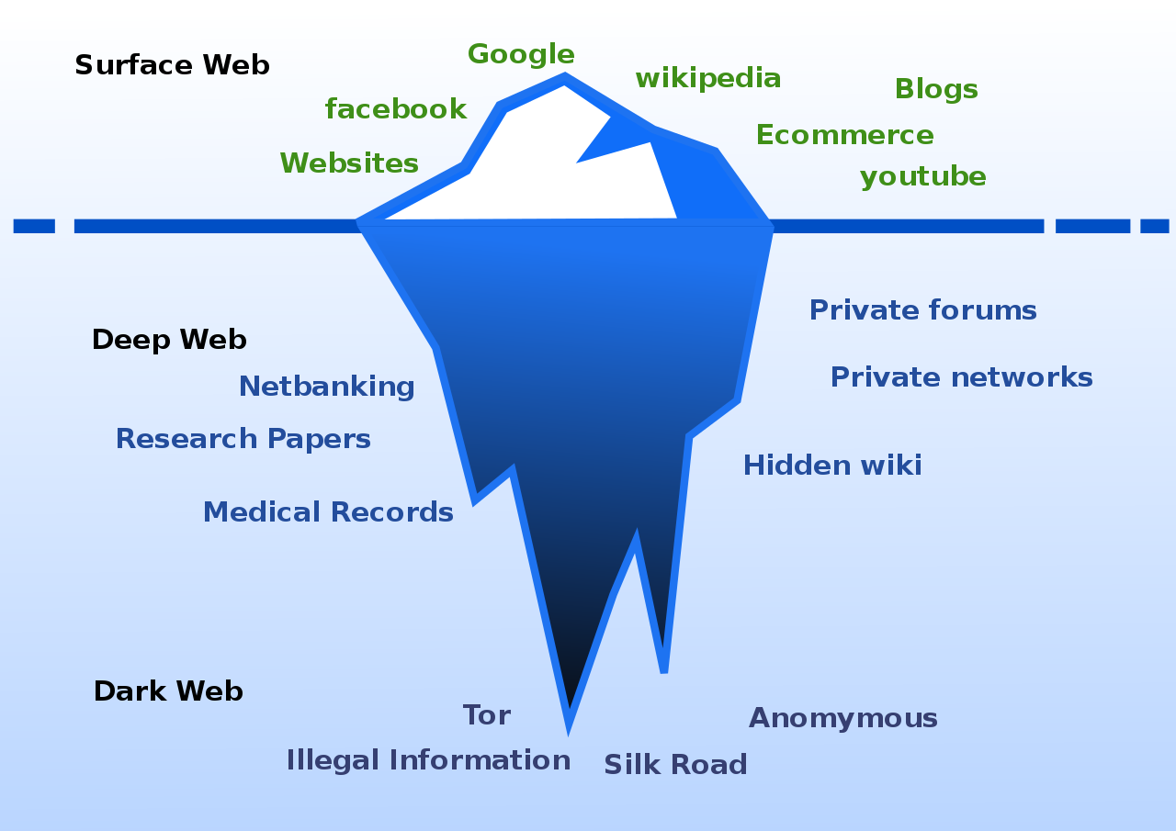
[1] https://quod.lib.umich.edu/cgi/t/text/text-idx?c=jep;view=text;rgn=main;idno=3336451.0007.104
For example many legitimate websites operate on the TOR network to allow access to their platforms for users in countries that have strong censorship:
- Facebook ( Social Media ) https://www.facebookwkhpilnemxj7asaniu7vnjjbiltxjqhye3mhbshg7kx5tfyd.onion/
- DuckDuckGo ( Search Engine ) https://duckduckgogg42xjoc72x3sjasowoarfbgcmvfimaftt6twagswzczad.onion/
- The New York Times ( News ) https://www.nytimesn7cgmftshazwhfgzm37qxb44r64ytbb2dj3x62d2lljsciiyd.onion/
- BBC ( News ) https://www.bbcnewsd73hkzno2ini43t4gblxvycyac5aw4gnv7t2rccijh7745uqd.onion/
- ProtonMail ( Email ) https://protonmailrmez3lotccipshtkleegetolb73fuirgj7r4o4vfu7ozyd.onion/
Indicators of Compromise - Search
For this lesson we’re going to focus on one company that is known worldwide for its ability to collect and analyze vast amounts of data from both open web and dark web sources; Recorded Future
source: https://www.hotspotshield.com/imgs/resources/tor-vs-vpn/how-tor-works.png
SANS, a private U.S. for-profit company founded in 1989 that specializes in information security, cybersecurity training, and selling certificates, created a poster showcasing the “Top 20 Coolest Careers in Cybersecurity!”
Certifications—especially with training—are another avenue for students to verify their skills, learn cyber tools, and increase their employability within the market. Albeit, experience will always trump certifications, this is a great way to learn more about the field without being employed per se. Employers place a heavy weight on the ability of candidates who demonstrate hands-on experience through gamified cyber platforms (HTB, THM, BTLO). These online resources can supplement your formal training after coming from a university or assist you in your career change from a non-IT-related background.
This interactive heat map from CyberSeek provides a granular snapshot of demand and supply data for cybersecurity jobs at the state and metro area levels (USA) and can be used to grasp the challenges and opportunities facing your local cybersecurity workforce.
With threat hunting falling within the information security analyst side of cybersecurity, the Bureau of Labor Statistics (BLS) is a great website to view the average salary.
High Paying Areas and Sectors
Threat-hunting salaries can range widely based on industries and location. Here are the top 5 industries and locations according to BLS, INFOSEC, and Talent.
Locations:
- Mississippi
- Virginia
- Georgia
- Texas
- Florida
Industries:
- Finance and insurance
- Computer systems design and related services
- Management of companies and enterprises
- Management and technical consulting services
- Scientific Research and Development Services
Certification List
Let's talk about some certifications that can help complement your Threat Hunting career! Disclaimer, the certifications/training below are not FREE like this course so think of this as supplemental information.
- CompTIA A+ - If you have not touched a computer in your life before or worked a traditional IT job (IT Support or Helpdesk), look into this entry-level certification by CompTIA. This two-part exam will measure your competency when it comes to hardware, operating systems, software troubleshooting, and real-world troubleshooting.
  - Training: CertMaster, Professor Messer, Jason Dion

- CompTIA N+ - Networking is extremely important when it comes to cybersecurity. This is a great foundation course to learn basic networking concepts including network services, routing technologies, and networking devices. If you are looking for something more advance check out the CCNA (Cisco Certified Network Associate).
  - Training: CertMaster, Professor Messer, Jason Dion

- eCTHPv2 - This is an expert-level certification by eLearnSecurity that tests students’ ability to threat hunt.
  - Training: INE

- GIAC GCFA - This is SANS’ own threat-hunting certification. It looks like it is paired up with advanced incident response lessons as well. This is the most expensive certification on this list so make sure you are having your employer pay for it if possible. Training is necessary to pass GIAC exams so buying the cert alone is not wise.
  - Training: SANS

Program List
Finally, let's look at some programs that can help complement your Threat Hunting career! Disclaimer, the programs below are not FREE like this course so think of this as supplemental information.
- Practical Threat Hunting Training by Chris Sanders - This is a foundational course from him that will teach you how to approach threat hunting using a proven, structured repeatable framework.

- Cybersecurity Threat Hunting for SOC Analysts by Vonnie Hudson - This is a blue teaming course on Udemy that will help students find covert threats in enterprise networks.

- Cyber Threat Hunting Training Boot Camp by INFOSEC - This is a 3-day BootCamp that will prepare you for the Certified Cyber Threat Hunting Professional (CCTHP) exam.
To find a file’s size via the linux command-line we will navigate to the directory where the file is, and use the command ls -lh which will list all files and their sizes.
In the below example we create a md5 checksum of the file TextFile2.txt on a Linux-based system using the command md5sum TextFile2.txt, giving us the hash 5d363d305385b3a71ca7eed28eb2c209.
Open a PowerShell terminal, move into the same location as the file you want to retrieve the hash for, and use the command Get-FileHash <filename>. By default, the hashing algorithm will be SHA256. But we can use the -algorithm flag to specify what algorithm we want to use, such as MD5 or SHA1.
Whilst Redline is an old tool, and limited in the sense that it can only be used on live machines using local admin access (as opposed to remotely conducting audits from a central server), it is a good tool to learn and understand the fundamentals of Threat Hunting.
Vulnerability Management is the process of identifying security flaws and vulnerabilities in software, reporting on these so they can be fixed, with a goal of reducing the risk and impact of cyber-attacks. This is a very important aspect of network and computer security, as it works to reduce the attack surface, a term used to describe the number of potential security flaws a malicious actor could exploit to cause harm to an organization. The process includes the following steps:

- Identification – Using vulnerability scanners, manual techniques, and asset discovery methods to identify and record systems (such as servers, desktops, laptops, mobiles, IoT devices), along with any security issues they have, with scores based on different factors (see CVSS scores).
- Reporting – Reporting these issues to appropriate stakeholders (such as system owners) so they can be addressed, and eventually resolved.
- Remediation – Having the security issues fixed by the system owner or technical owner so that the security flaw is no longer present. Different methods can be used to remediate vulnerabilities, such as security patches, reconfigurations, or mitigating controls.
- Reassessment – Scanning or manually checking to ensure the security issues have been successfully fixed.

Materials
- [1] https://outpost24.com/blog/why-is-vulnerability-assessment-so-important
- https://www.compuquip.com/blog/importance-of-vulnerability-management
- https://www.darkreading.com/application-security/vulnerability-management-the-most-important-security-issue-the-ciso-doesnt-own/a/d-id/1330734
https://CVEDetails.com is a security vulnerability database that has lots of information and can allow us to search for specific CVEs, or even look at vulnerabilities sorted by release date.

https://nvd.nist.gov is the National Vulnerability Database, created by the National Institute of Standards and Technology.
Here I am provided with more information, such as the versions affected, the type of vulnerability (use after free) and what successful exploitation will result in (remote code execution).
In this section, we’ll be teaching you how to use Nessus Essentials, a free version of the enterprise-grade vulnerability scanning platform, Nessus. Please remember you may only use this version for personal projects at home, and using it in a business environment is a breach of Tenable’s licensing. This tool is great to use during certification exams (if it’s permitted! Check before using it), and performing vulnerability discovery on platforms such as HackTheBox.
If you’ve previously used Nessus, you may get an error stating you have a corrupt database. To fix this, you need to kill the service using service nessud stop, remove all Nessus files, download the latest version, and install it again. To delete all files for a clean re-install, use the following command in the terminal: rm -rf /opt/nessus (recursively remove everything in the Nessus directory, opt/nessus)
This section will cover the OpenVAS, a vulnerability scanner, created and maintained by Greenbone Networks. Whilst Nessus is usually the popular choice for vulnerability scanning, OpenVAS is still a tool used by Vulnerability Analysts. Whilst this scanner is not free, Greenbone offer a free live demo, so you can get an idea of how everything looks in a production setup.
Head over to https://livedemo.greenbone.net and use the username livedemo and password livedemo to sign in.
n this section, we’ll be teaching you about WPScan, a free (non-commercial) black box WordPress vulnerability scanner. Over one-third of ALL websites use WordPress. That’s a huge amount. So for site owners, this tool is great to identify any security flaws in the many features that WordPress allows, such as Plugins (3rd Part Extensions), Themes (Appearance Templates), and Users. Unfortunately it’s not easy to get hands-on with this tool, as there are no sites hosted on the internet that expressively allow scanning (whereas sites like scanme.nmap.org are designed for tool testing).
There are some additional parameters we can pass to WPScan to fine-tune what information you’re looking for specifically, such as vulnerable themes, vulnerable plugins, and user enumeration.
- wpscan –url <site.com> –enumerate vp
- wpscan –url <site.com> –enumerate vt
- wpscan –url <site.com> –enumerate u
- Disk Analysis & Autopsy (THM): This is a free lab that covers the Autopsy tool, it’s good, and provides solid practical knowledge of the tool. There are not a lot of resources for autopsy, so this free one is excellent to complete prior to the exam.
Link: https://tryhackme.com/room/autopsy2ze0
- Splunk: Exploring SPL (THM): This room is excellent to get one’s hands dirty with the Splunk tool, and will provide one with realistic practical insight into how the fundamentals of the tool work, and how the tool may be leveraged for SOC operations.
Link: https://tryhackme.com/room/splunkexploringspl
- Conti (THM): This is additional Splunk practice that goes a bit above what can be expected in the exam, if you manage to do this and build good notes you will be in a good position for the Splunk portion of the exam.
Link: https://tryhackme.com/room/contiransomwarehgh
Paid Resources:
- Autopsy (THM): This is a paid lab that covers the Autopsy tool, it’s good, and provides an overview, and walkthrough of how one may leverage the tool for a basic forensic investigation. I feel this is a good substitute for additional training, as well as reference to understand tool usage for those who no longer have access to the BTL1 lab, and course material.
Link: https://tryhackme.com/room/btautopsye0
- Incident Handling With Splunk (THM): This is a paid lab that covers several methods, and queries one may leverage when using the Splunk tool during an investigation, I found this to be the most useful paid resource I leveraged.
Link: https://tryhackme.com/room/splunk201
Exam Tips:
- Build playbooks for each of the exam tools: These playbooks, should contain information on how to use the tool for a specific purpose, and include command format examples. It's a great way to both create a reference you can refer to during the exam, as well as helping cement what you learned over the BTL1 course.
- Read the instructions carefully: Read the BTL1 exam instructions, and questions carefully, rushing, and not doing so, will potentially cause you to answer some questions incorrectly, or waste precious time.
- Challenge the exam while you still have course access: This will give you an edge if you need to refer to a specific tools usage, as it will be easier to find to specific tool module while you have access to the course interface.
- Remember you may request a manual review of the results: If you feel you answered a question correctly, but it was marked as incorrect, remember it is possible to request a manual review. I did this, and my initial 85% grade was increased to 100% thereafter.
- Write a report as you conduct the exam: Although not required, I feel it is still important to write a report of the steps you took to solve each question. This is valuable for three reasons, it will let you outline your process to determine if it makes sense, it gives you something to reference if you don't answer a question correctly to see where you went wrong, lastly if the shit hits the fan and the exam crashes, you'll have all your answers still available in this report.
- Understand the MITRE framework, and google dorking: These two skills are important for securing the gold coin, you're likely going to need to do some outside research during the exam to solve some questions, having the muscle memory to do so properly on the fly is integral.
- Read ahead of you get stuck: If you get stuck on a question read ahead to the next one, it may be possible to get a hint regarding the prior question based on the next one.
- Understand the Splunk interface: It's important to understand how the Splunk interface itself may be used to delineate information, understand the specifics of the tool, and how different features may be used to display information. To clarify I'm not talking about SPL, I'm specifically referring to the tool interface.
- Don't overthink things, keep it simple: The exam questions aren't meant to trick you, all of the questions have a simple method to obtain them, the answer is going to be the obvious one, don't overthink things.
- The Wireshark, and Splunk sections require a bit more: The exam portion featuring these tools requires a little more advanced knowledge for some questions than what is discussed in the BTL1. For that reason focus on these tools, and the outside resources mentioned in this guide when building your playbooks.
VPs1fuF2vI-7xoOVZ7L5m
ezZV9D7Ym0-dtxBZ8HjOa
4LU1ODst0f-1TlpUnLald
J8ybTXxrd8-OMsOJBEobG
Y1Cjk6M4m4-qBg2SDQWos
gMDqwI7Kbd-5gYB5BOxnL
JzjCyPkvZD-PrmtTQ5V8u
XptzbPIJuN-caslAITHSo
Recovery code for Security Blue Team account.

